OPA Instance with ORM stack

Contents

1. Introduction 3
2. Workflow diagram to deploy the stack 3
3. Create stack for Process Automation Instance 4
4. Plan the Job 6
5. Apply the Job 8
6. Verify in the Console 9
7. Destroy the stack 10

Introduction

Oracle Cloud Infrastructure Process Automation is a multi-tenant Oracle Cloud Infrastructure (OCI) service. Use the low-code designer environment to quickly create structured and dynamic process workflows. Leverage capabilities such as resuable business rules, configurable web forms, connectivity to prebuilt application integrations, and much more to simplify repetitive tasks and automate your business processes.
Use Oracle Cloud Infrastructure Process Automation to rapidly design, automate, and manage business processes.
- Key capabilities include:
- Structured and dynamic process modeling
- Decision modeling
- Connectivity to outside apps and integrations
- Web forms
- User task management and tracking

Workflow diagram to deploy the stack

Below diagram shows how the Terraform Artifact are applied in the OCI. While creating a ORM stack, using terraform deliverables Init, Plan and Apply is the flow to provision the resource in the OCI. We can have the deliverables in any of below.

- GitLab/GitHub Repo
- Bitbucket
- Can be in folder/.zip in the local disk
- Object Storage Bucket
- Can be in compartment
- Oracle provided Template


Create stack for Process Automation Instance
Go to OCI Console Developer Services Resource Manager Stacks select the compartment Create Stack

My Configuration Folder Browse Select the “OPA_Instance” folder that contains the terraform Upload

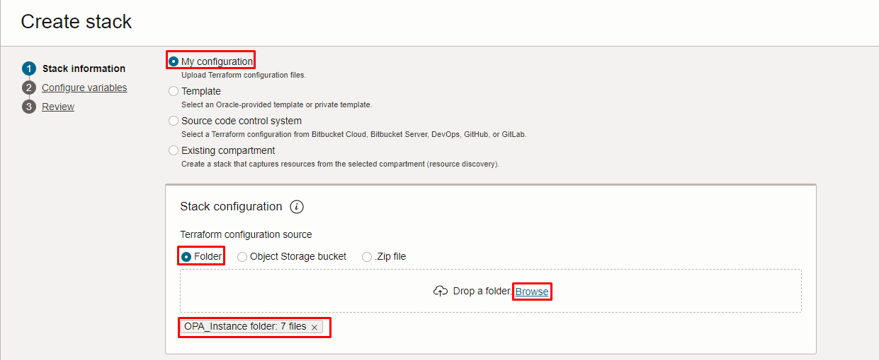
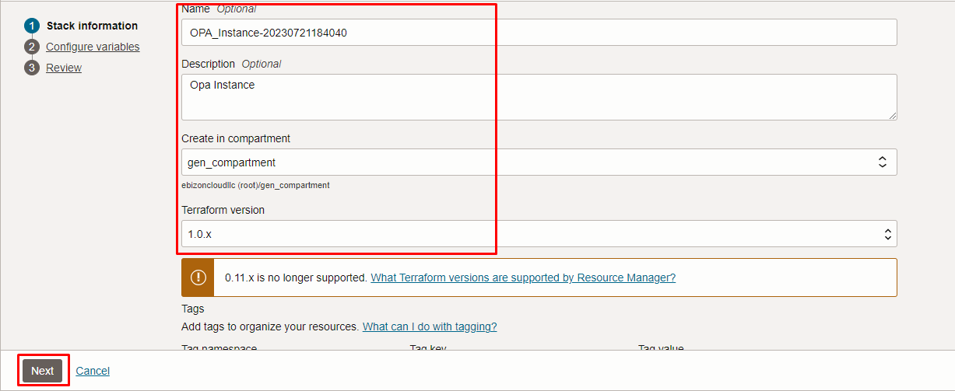

Click “NEXT”

Select the parameters as per the below screen,
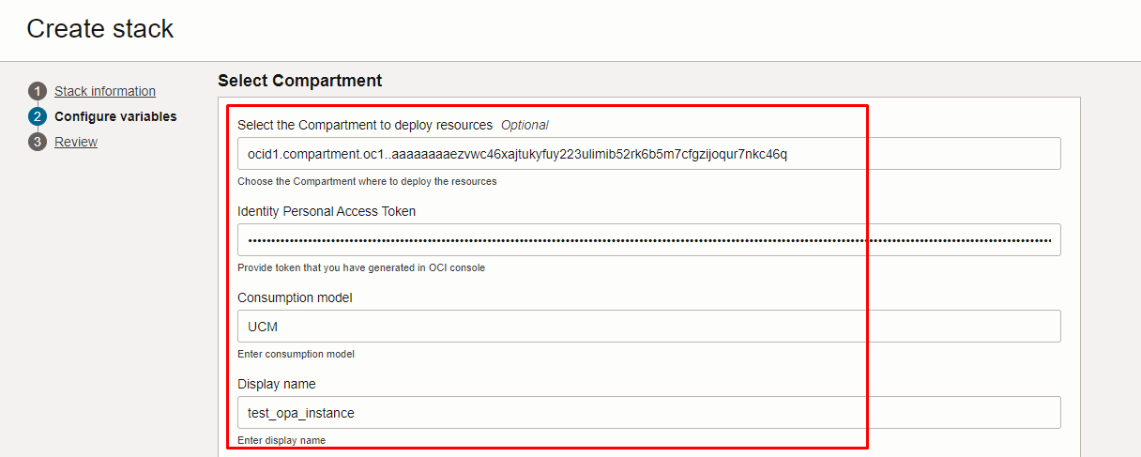
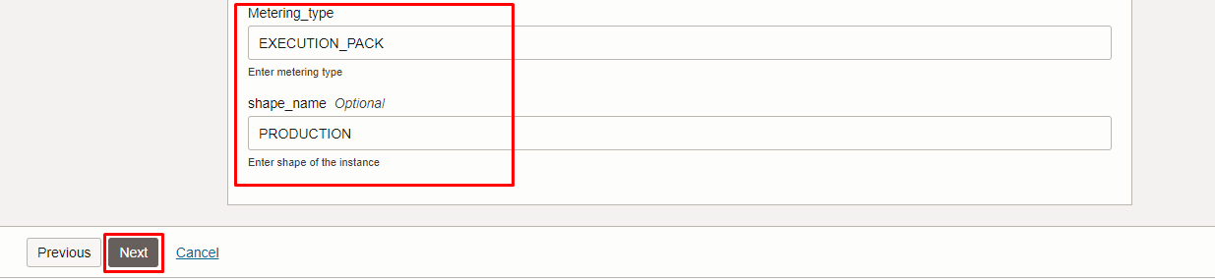

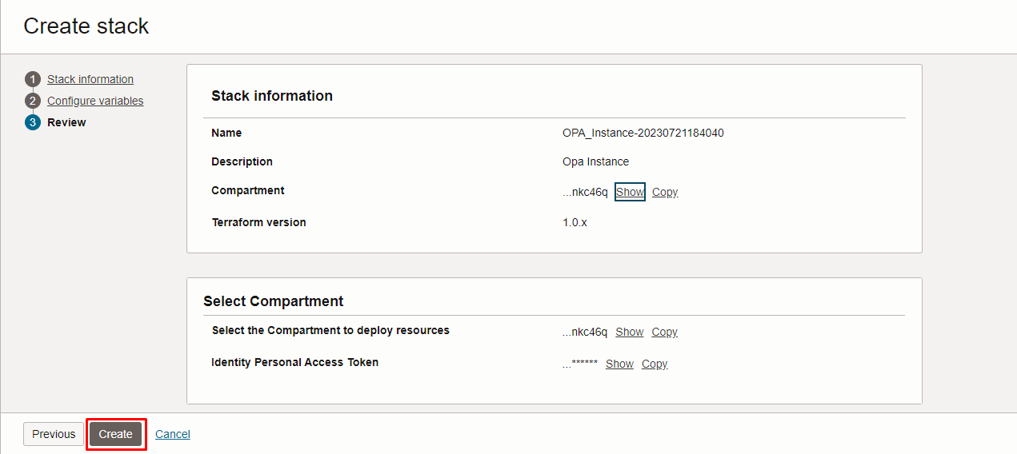

Click “NEXT” Click “CREATE”

Plan the Job

Click the “Plan”

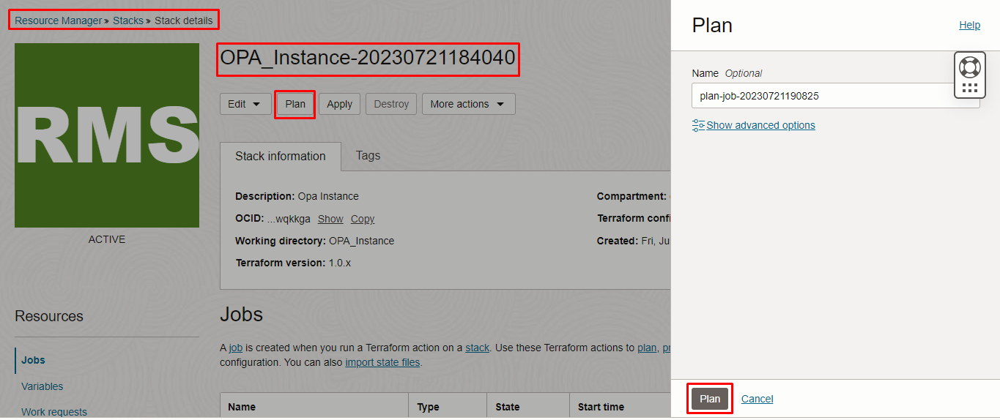
Verify the Plan is successful.

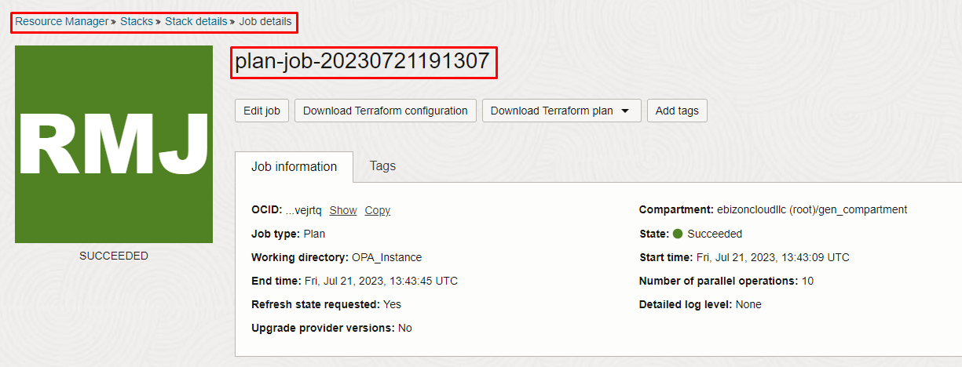
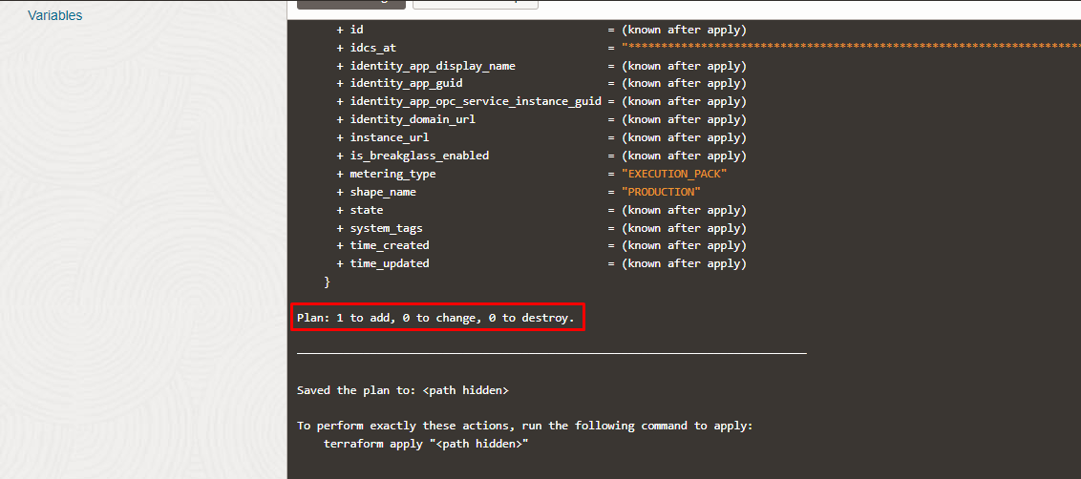

Apply the Job

Once the “plan” is success, now click “Apply”

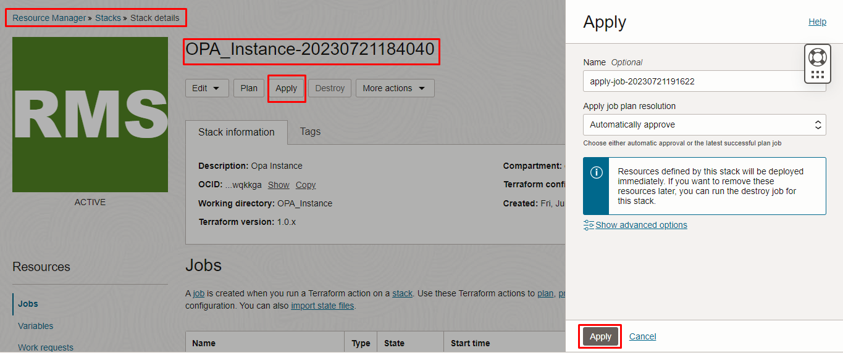

Verify the Apply is successful.
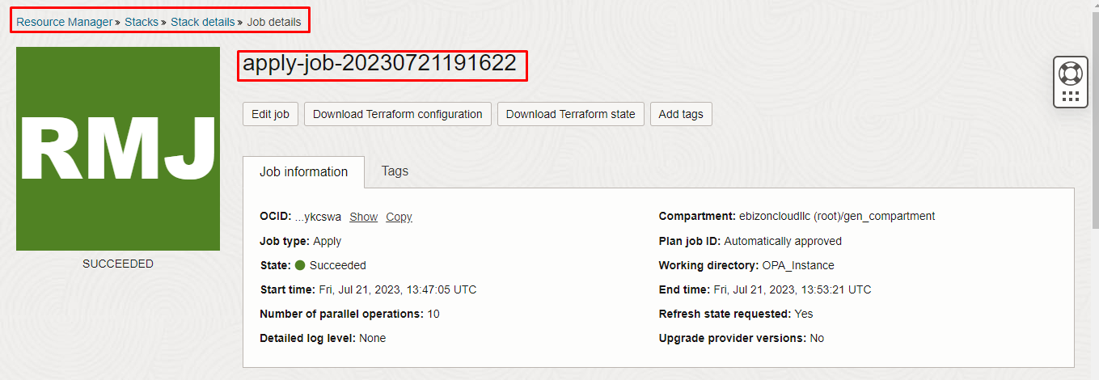
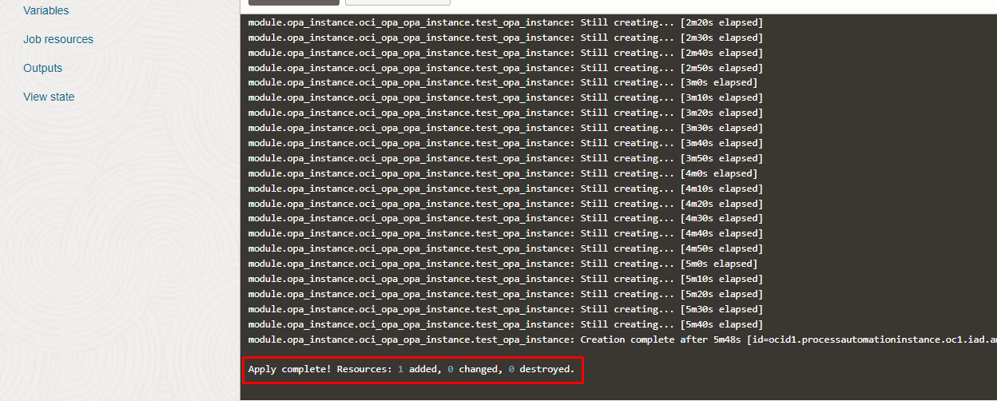

Verify in the Console

Go to OCI Console Developer Services Process Automation

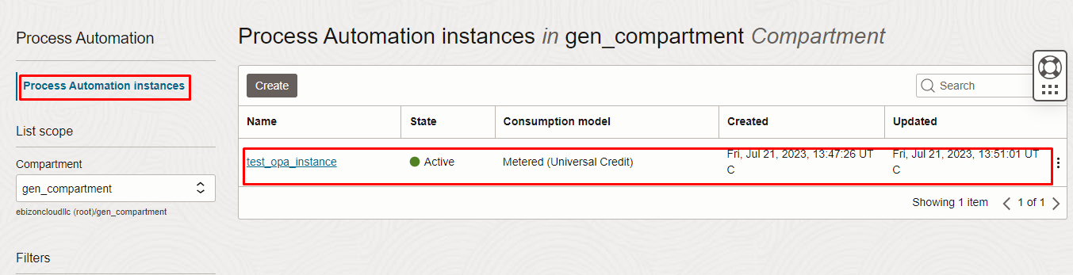
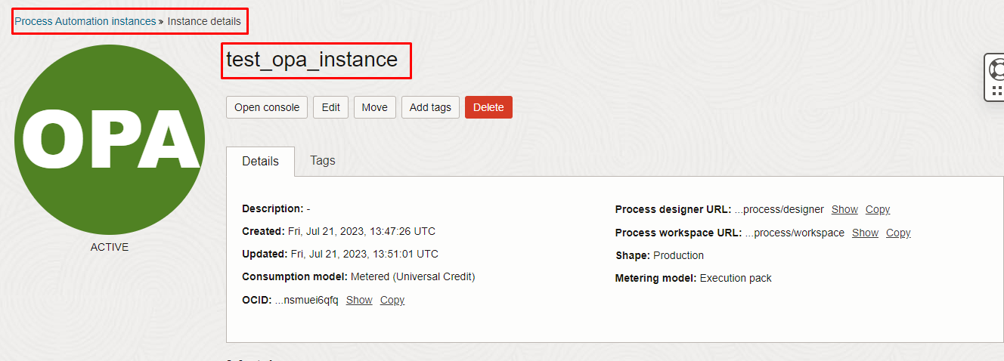

Destroy the stack

Create a destroy job in Resource Manager to release resources associated with a stack and clean up the tenancy. Once destroyed data cannot be recovered from resources.

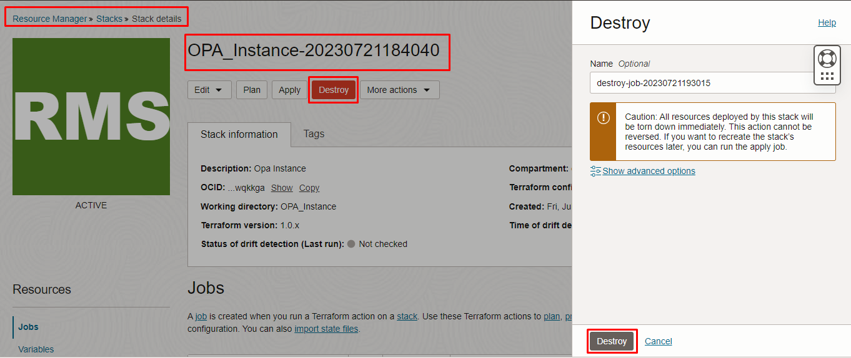

#########END#########

